
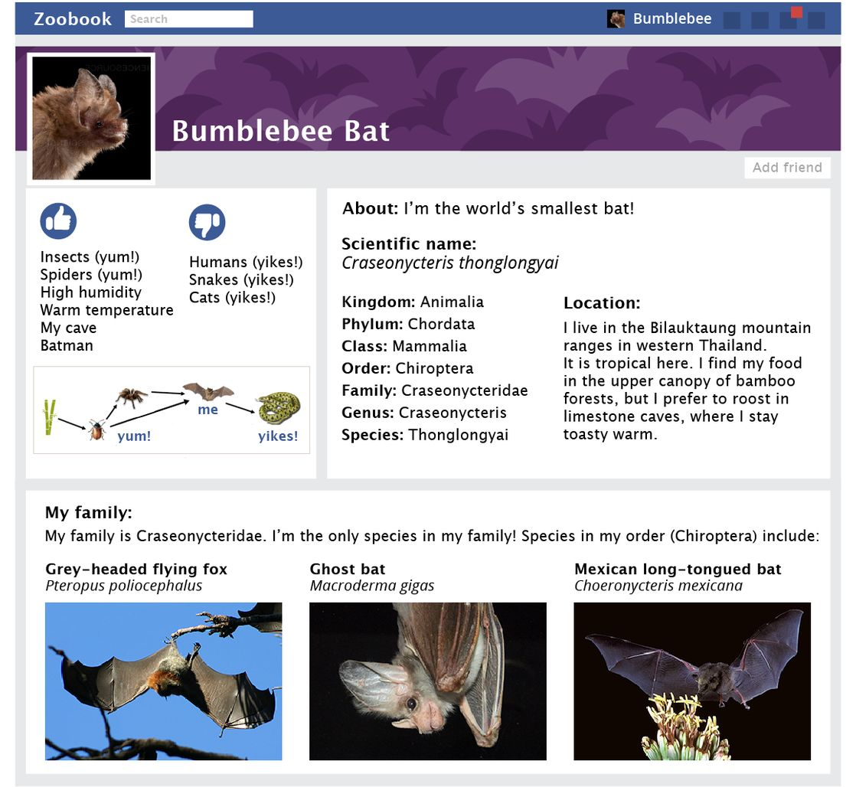

2019 Autumn Term

Year 7 Biological Science

Animal Profile
Learning Intention: Create a social media profile for an animal that describes how it is classified.

Success Criteria: Students will:
research an animal and its classification
create a social media profile of the animal
reflect on their learning by identifying what they did well and what they can improve on
Your Task
Choose an animal. Research the animal's classification and use the template provided in STILE to create a social media profile. See the example below.

Criteria
Your animal profile must include:

- a picture of the animal
- common name
- scientific name
- classification: kingdom, phylum, class, order, family, genus and species
- geographical location
- other species in the family

Your animal profile should be neatly presented and creative. You may wish to include other information about the animal to add interest. For example:
- its habitat
- what it eats
- its predators

NAME: TOTAL: $\frac{}{14}$
Animal Profile
 | 0 | 1 | 2
Names | Not shown | Either the common name or scientific name is provided, but not both. | Both the common name and scientific name are provided.
Classification | Not shown | The animal is partly classified in terms of kingdom, phylum, class, order, family, genus and species. | The animal is fully classified in terms of kingdom, phylum, class, order, family, genus and species.
Images | Not shown | A picture of the animal is included. | A picture of the animal is included. Additional images are used to add creativity and interest.
Geographical Location | Not shown | The species' location has been identified. | The species' location has been described or illustrated with a map.
Related Species | Not shown | One other species has been identified with the same family classification. | Two or more species have been identified with the same family classification.
Presentation & Creativity | Not shown | The animal profile is neatly presented. | The animal profile is neatly presented and includes extra information or creative elements.
Reference | Not shown | At least three references given. | At least three references given in correct format.

Year 7 Biological Science

